Enabling automation
if you want SambaPOS to execute Automation Rules while creating a ticket you need to use Terminal API instead.
1. Registering A Terminal
This step starts a session on SambaPOS server and it will work like a regular SambaPOS client. For this reason you need to define some parameters while registering a terminal.
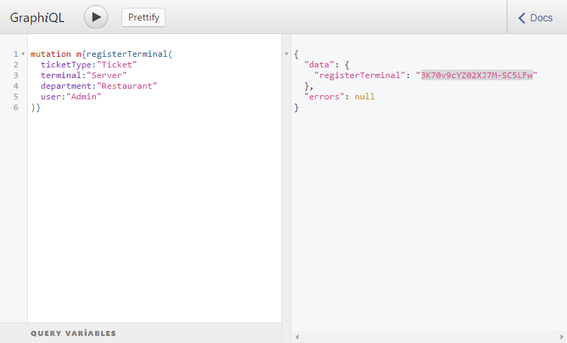

mutation m{registerTerminal(
ticketType:"Ticket"
terminal:"Server"
department:"Restaurant"
user:"Admin"
)}
So this ticket will work like a ticket that have a “Ticket” ticket type, created on “Restaurant” department through “Server” terminal by user “Admin”.
This mutation will respond with a terminal Id like:
3K70v9cYZ02XJ7M-SC5LFw
Instead of re-sending user, ticket type, etc, parameters we’ll use this ID while executing next mutations.

2. Starting a ticket
On this step we’ll execute createTerminalTicket mutation to start a new ticket.
On this step you can also open an existing ticket to add new orders.
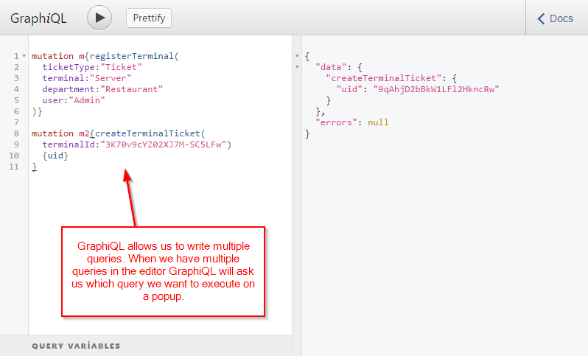
When we execute second query server responds us with the unique id of the Ticket. That means ticket created successfully and we can add orders.

3.Adding Order
We’ll use addOrderToTerminalTicket to add orders.
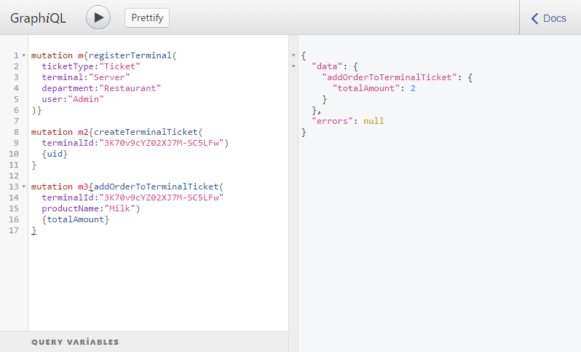
mutation m3{addOrderToTerminalTicket(
terminalId:"3K70v9cYZ02XJ7M-SC5LFw"
productName:"Milk")
{totalAmount}
}
This mutation adds Milk order in the ticket. It is important to remember each mutation will execute related SambaPOS rules if any. So if SambaPOS is configured to add “Free Cookies” product when a Milk is added your mutation will also trigger that
rule.

4. Closing Ticket
Until this step ticket stays in Server Memory in draft state. On this step we’ll close ticket to persist it to database and execute related “Ticket Closing” rules. For example if tickets auto prints on ticket close it will trigger ticket prints.
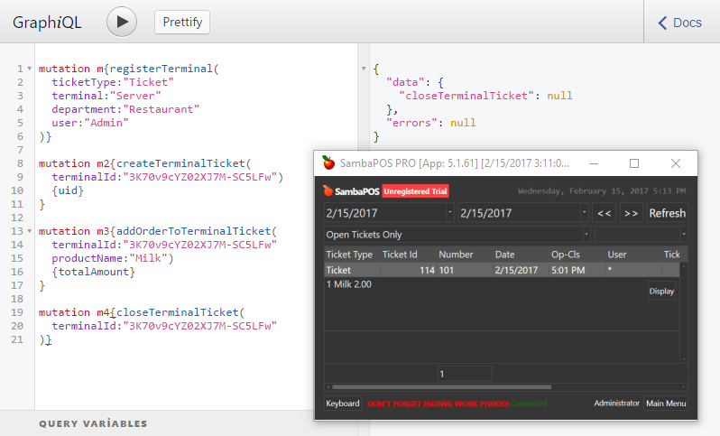
Now our ticket appears fine in SambaPOS.
You’ll notice User appears as * in SambaPOS. I intentionally set user name as Admin instead of Administrator. If you see Users named as * you can check RegisterTerminal mutation to ensure user name set correctly.
I executed this mutation to close the ticket.
mutation m4{closeTerminalTicket(
terminalId:"3K70v9cYZ02XJ7M-SC5LFw"
)}

5. Unregistering Terminal
If we won’t create additional tickets we can unregister terminal to close our session on SambaPOS side. If you keep a session idle too long it may expire.
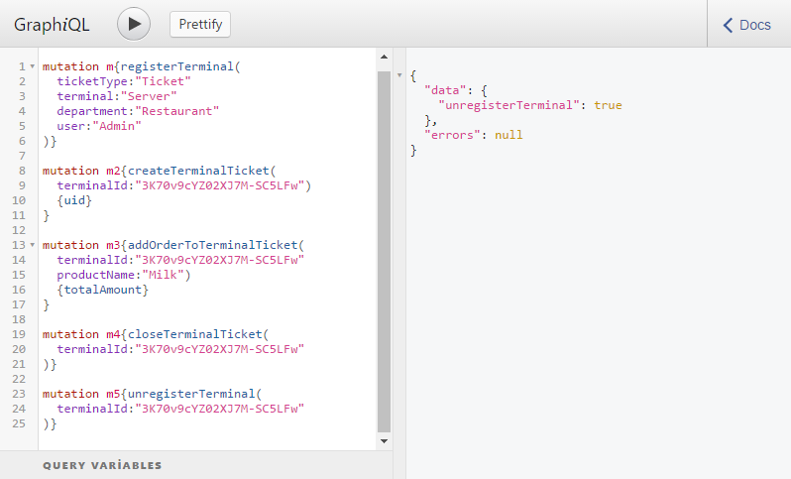

mutation m5{unregisterTerminal(
terminalId:"3K70v9cYZ02XJ7M-SC5LFw"
)}
More Info
This is what we need to do to create tickets as if it created through a SambaPOS terminal. You can use API documentation for more info about api functions you can use while creating tickets.
Here you can find all mutations mentioned on this section.
mutation m{registerTerminal(
ticketType:"Ticket"
terminal:"Server"
department:"Restaurant"
user:"Admin"
)}
mutation m2{createTerminalTicket(
terminalId:"3K70v9cYZ02XJ7M-SC5LFw")
{uid}
}
mutation m3{addOrderToTerminalTicket(
terminalId:"3K70v9cYZ02XJ7M-SC5LFw"
productName:"Milk")
{totalAmount}
}
mutation m4{closeTerminalTicket(
terminalId:"3K70v9cYZ02XJ7M-SC5LFw"
)}
mutation m5{unregisterTerminal(
terminalId:"3K70v9cYZ02XJ7M-SC5LFw"
)}
emre 2017-02-24 13:15:28 UTC #8

